REPORT

1. CONECTED SPRING BOOT BACKEND USING RETROFIT

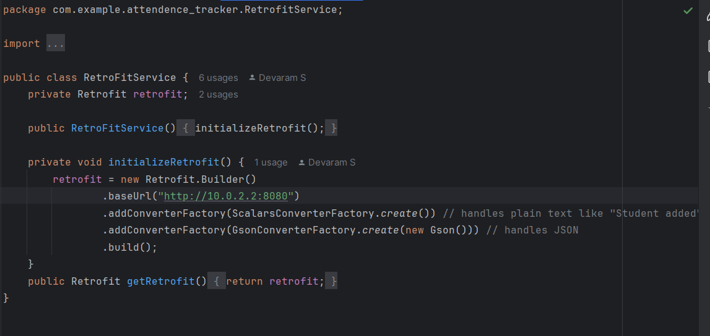

1. DATABASE STRUCTURE

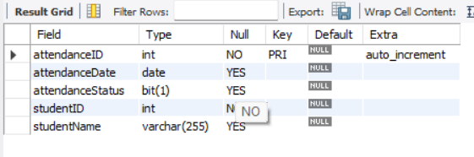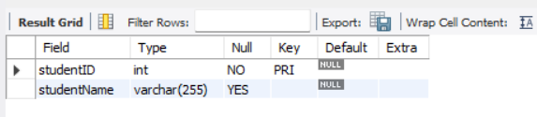

1. BASIC RETRIEVAL FROM BACKEND AND SAVING TO BACKEND

